Assignment: Creating and Scheduling a Job on Databricks using Notebooks –

Task 1 :

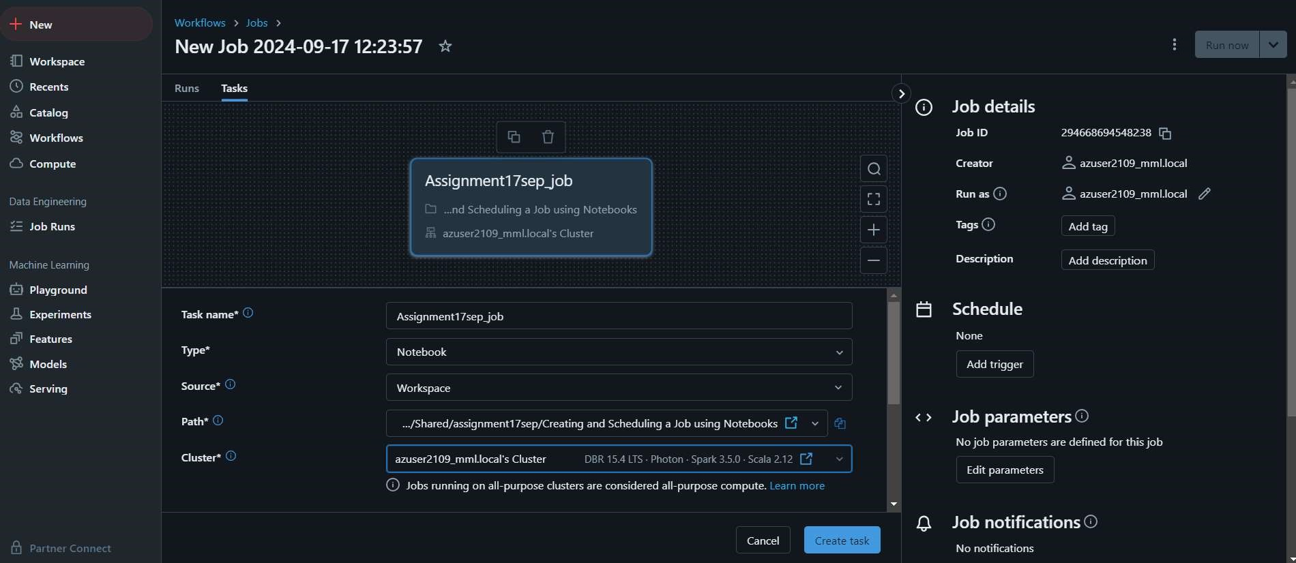Prepare Your Notebook

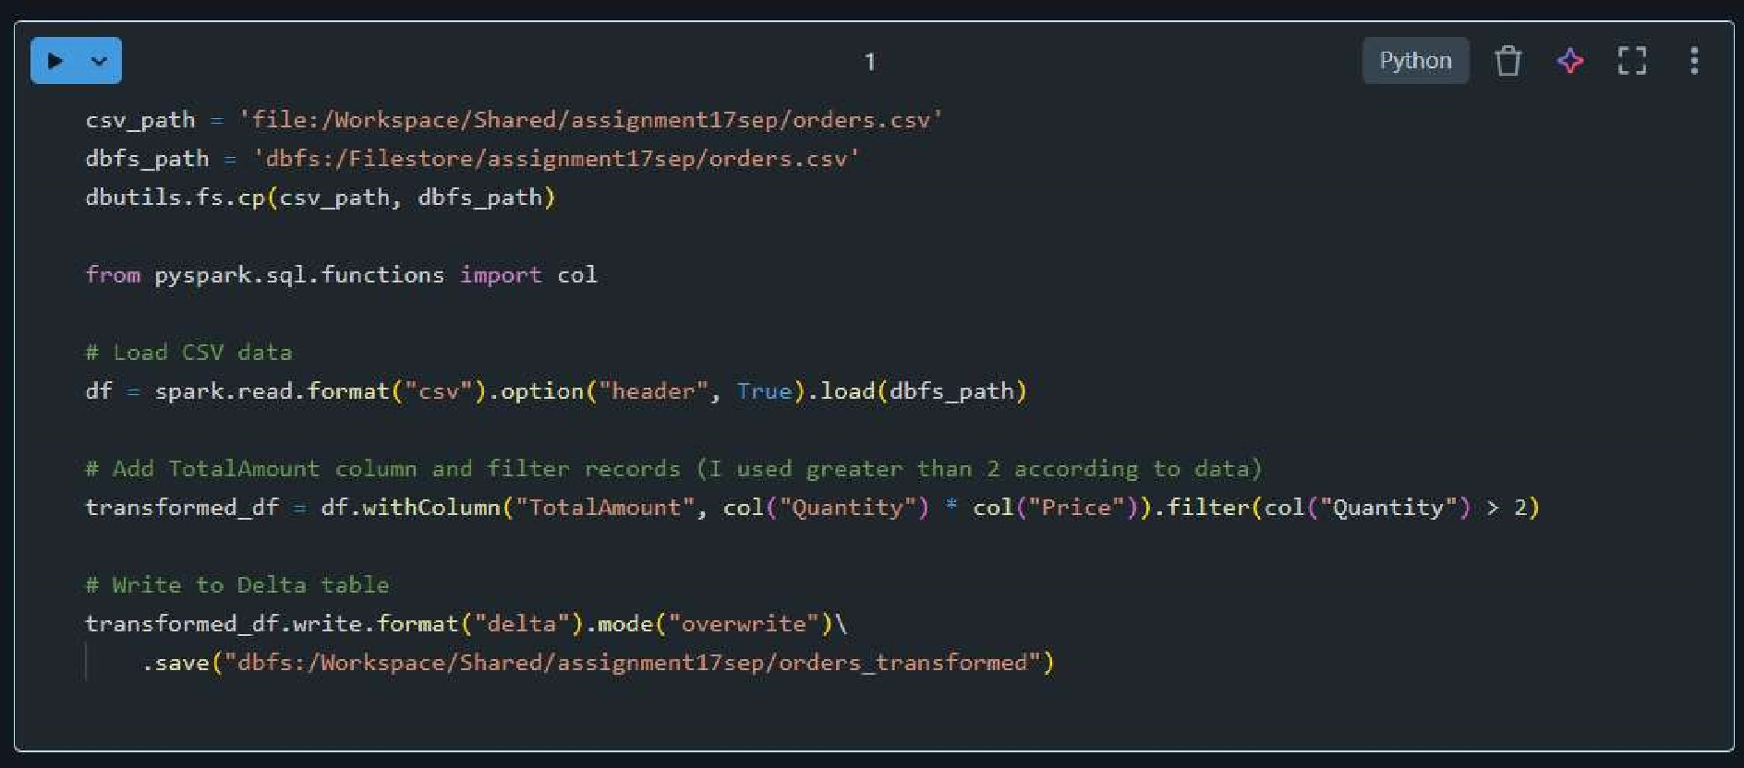

Task 2:

Creating a Databricks Job

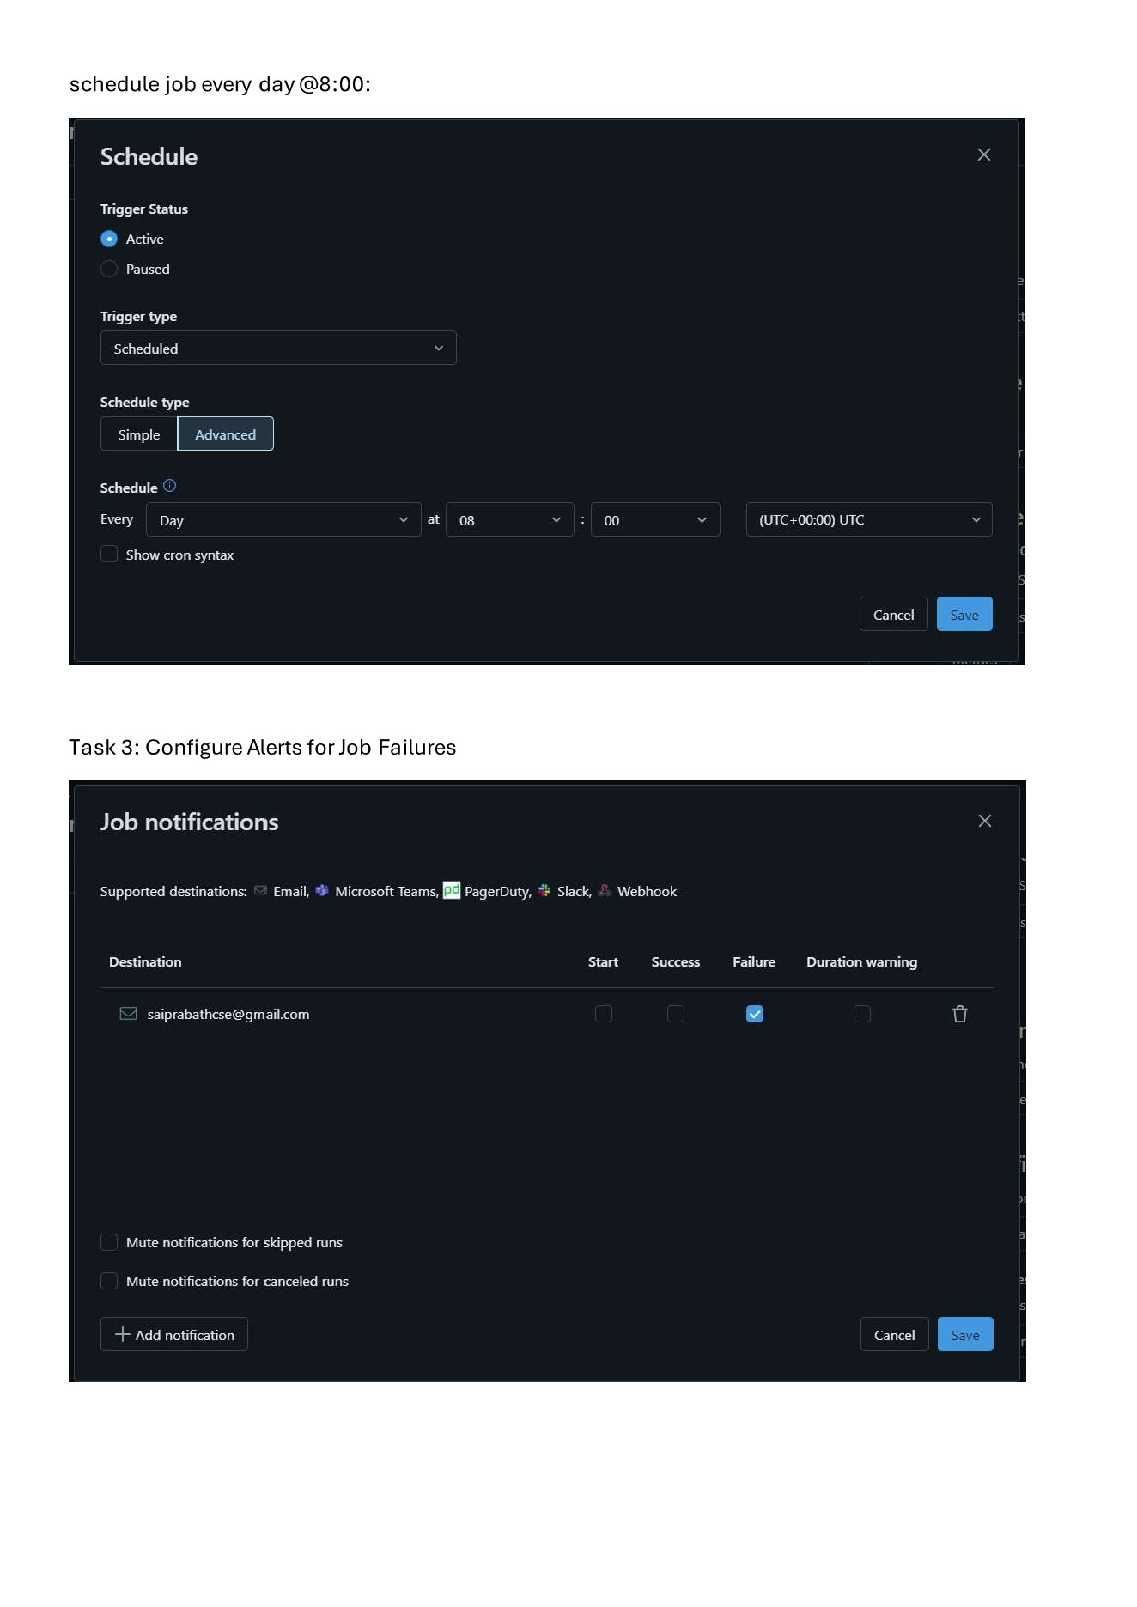

day

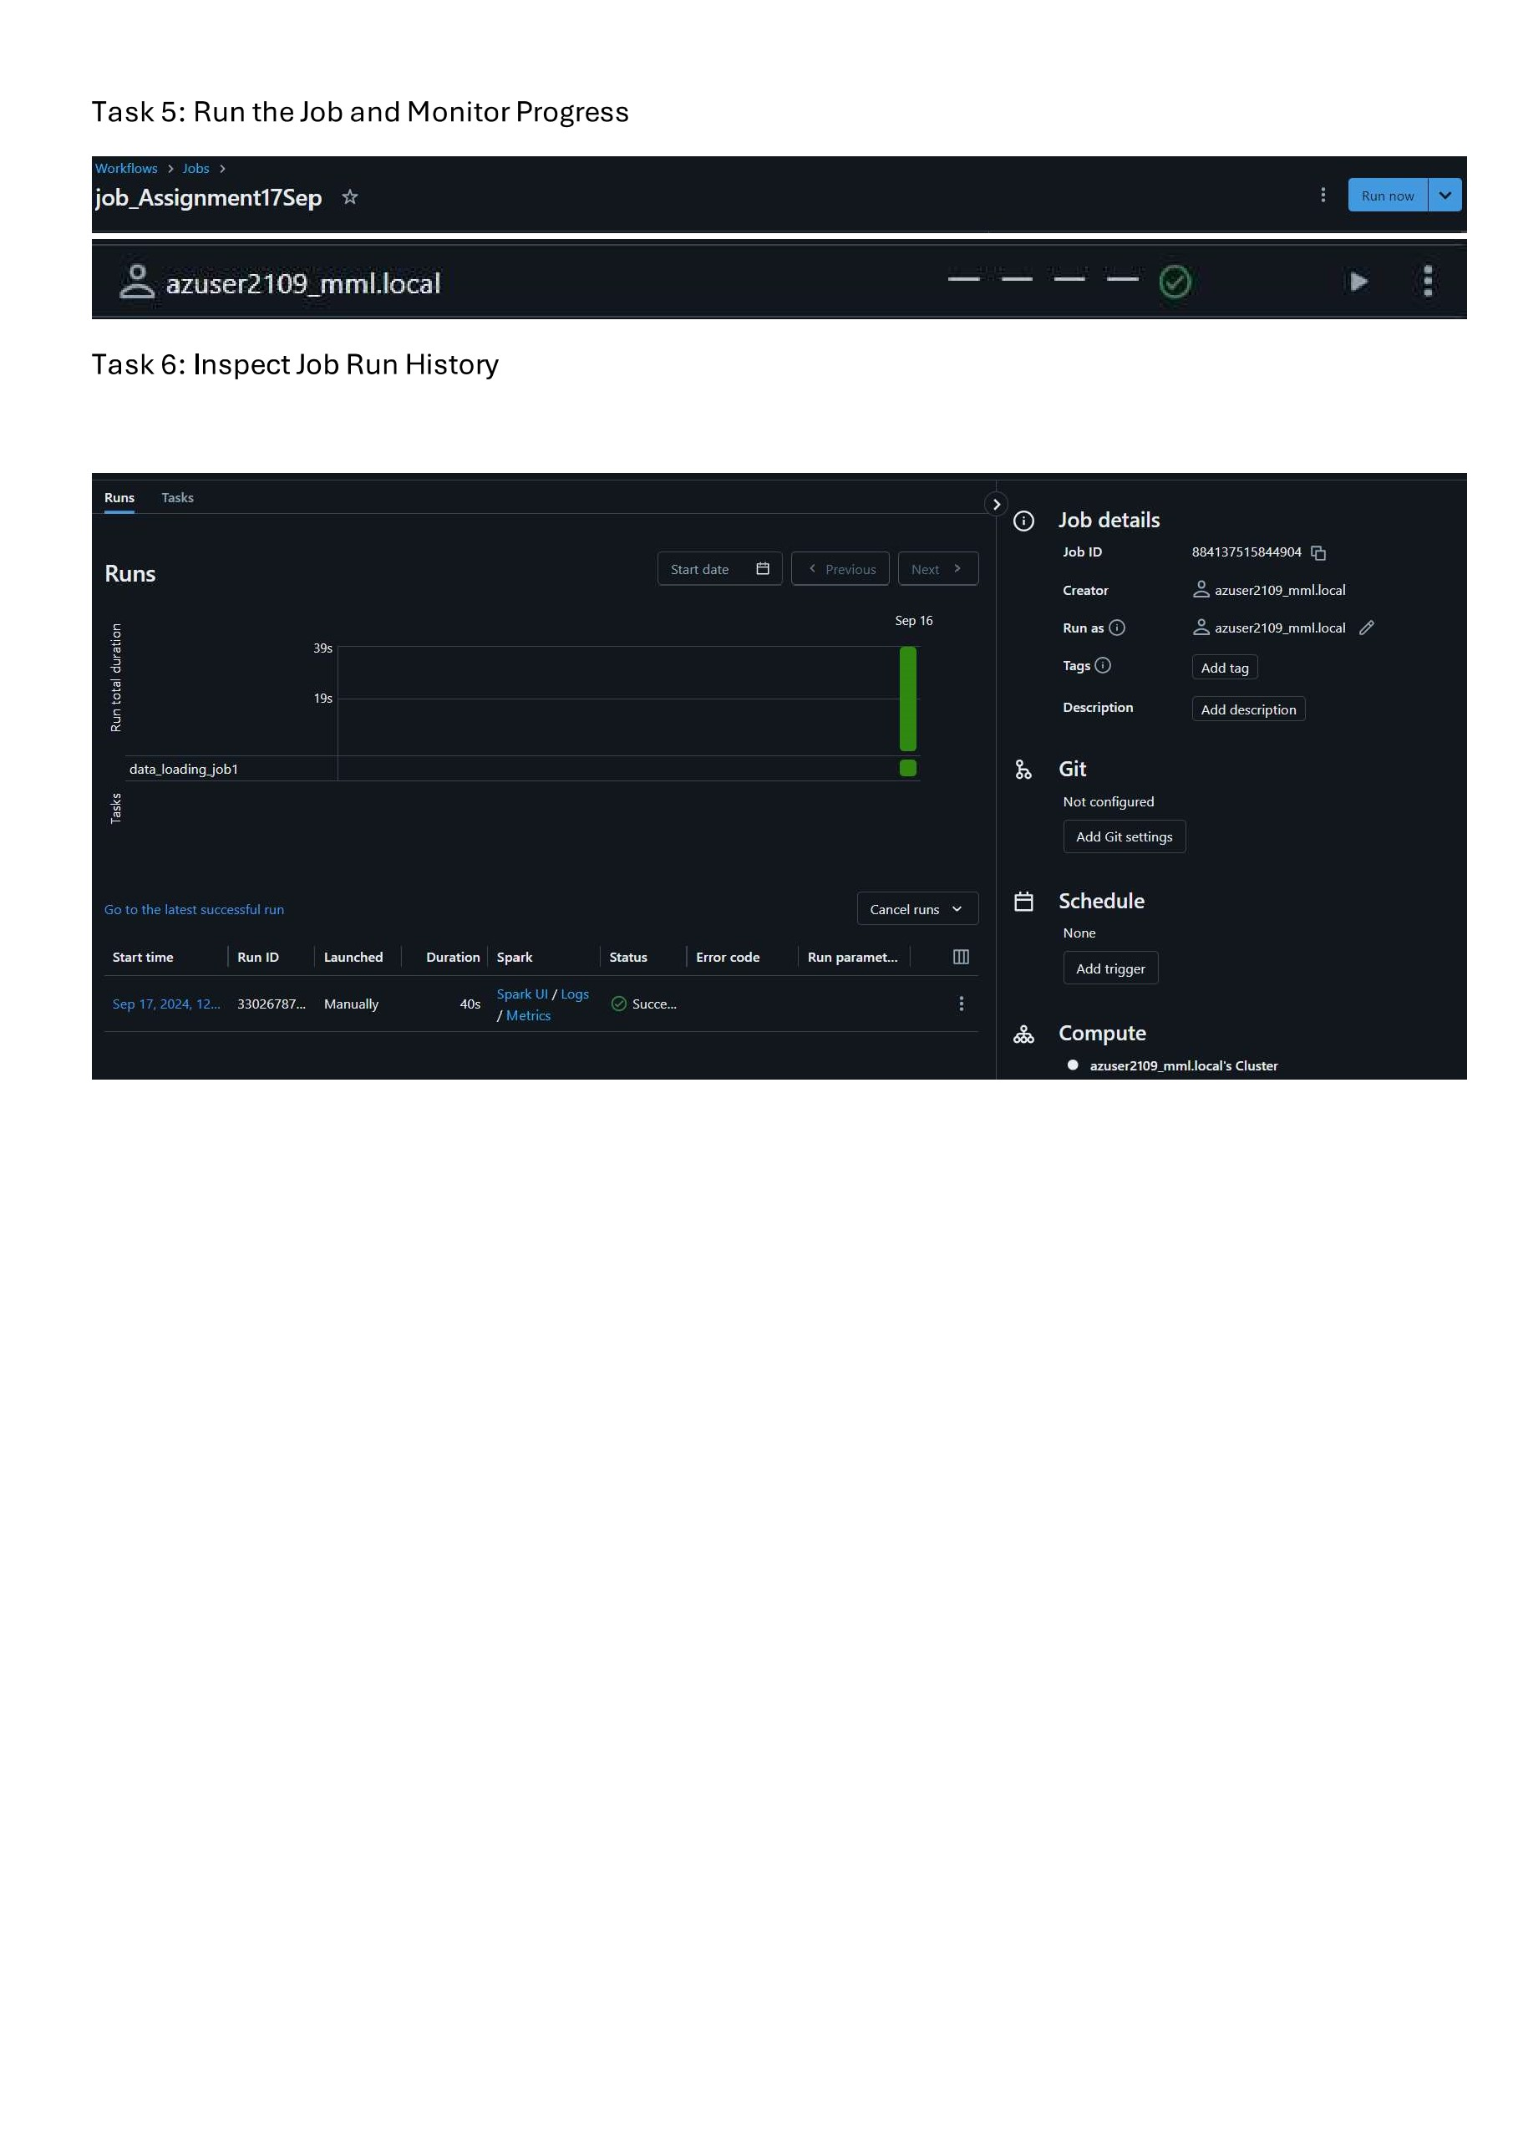

Task

5:

Run

the

Job

and

Monitor

Progress